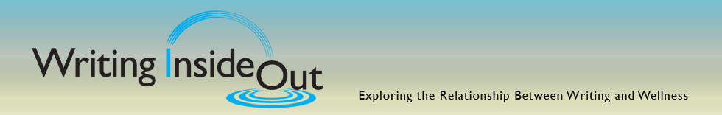

What A half-day experiential workshop in writing personal narrative.

Participants will be introduced to the research behind expressive writing, its key biological and psychological benefits, and the suggested guidelines for a beneficial writing experience as they engage in hands-on writing practice. We will apply “left brain” logical and “right brain” imaginative, as well as sensory and intuitive writing techniques for greater personal insight and growth. Participants should bring a pen and notebook.

When Saturday, March 16, Registration @ 8:30 a.m. Workshop 9- 1 p.m.

Where Unity | 1852 Buenaventura Blvd., Suite #6 | Redding

Cost $39. Pre-registration is requested but walk-ins are welcome.

Facilitator

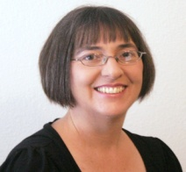 Claudia Mosby is a freelance writer and educator. Her column on midlife appears in the Record Searchlight and she is a contributing feature writer to several Northern California newspapers and magazines. She is the founder of Voices from Inside Shasta County, a writing workshop for incarcerated women. A past Research Assistant at the Benson-Henry Institute for Mind Body Medicine, Harvard Medical School, she has worked extensively with organizations and agencies involved in health care delivery and education. Currently she serves as a Prayer Chaplain at Unity in Redding.

